Written Questions
Team Name: ______________
1. How attackers gained access?
2. How attackers maintained access?
3. What was their purpose?
4. Are they still here?
Determine the profile and sophistication level of the attack.
5. Determine how program interact with network.
6. Determine how program interact with the host system.
7. Determine the infection mechanism.
8. Build a map and identify significant clusters
9. Determine relative links and their closeness centrality
10. Produce an informed predictive model of the Maskirovka network cell
11. Determine cell network members and their role
12. What were the significant financial transactions?
13. Who made them and why?
14. Identify key IOCs related to the Electroput Grozny using opensource threat intel feeds?
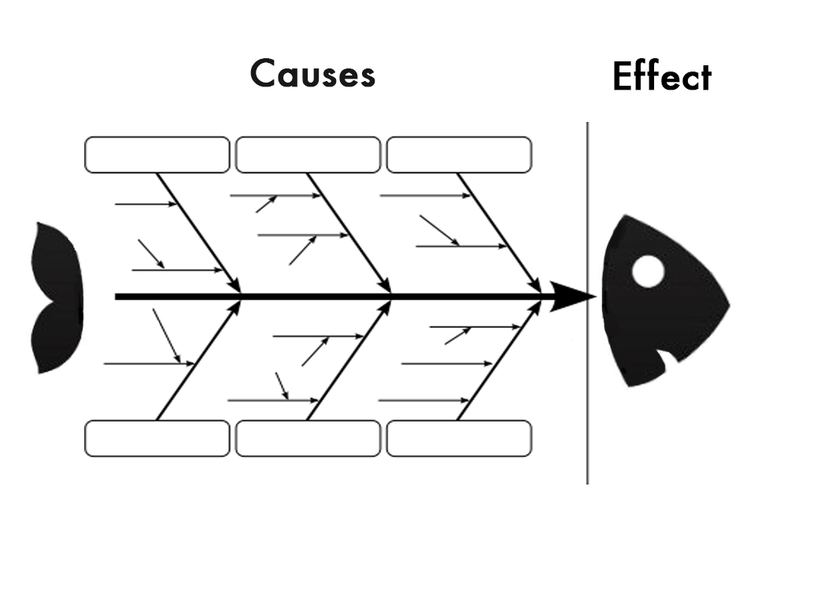
Complete the diagram

